**Summary for the discussion**

**Background**

1) How can spatial patterns of vegetation be characterized in semi-arid systems?

We are currently using three indices to characterize these patterns. The first is patch size distributions which has been regularly used for this purpose. The next is the distribution of distances to the nearest neighbouring patch. We are also interested in the relationship between the amount of biomass at a fixed distance from a patch and the size of the patch itself.

2) What can these indices tell us?

Different mechanisms by which plants interact and organize themselves in space can produce different spatial patterns. Intraspecific facilitative interactions have been theoretically inferred to produce patch size distributions which follow a power law. Theoretical predictions for the other indices as well as more complex interactions are lacking. By characterizing these patterns worldwide and comparing them with theoretical predictions, we can understand both the underlying mechanisms as well as the stability of these ecosystems.

3) How do we statistically fit the distributions?

We use the maximum likelihood methods described in Clauset et al 2009 to fit power law, exponential and lognormal distributions and compare the fits.

These methods have rarely, if ever, been used in this context despite their proven superiority. For power law fits, the dominant method is to fit a regression line to log transformed ICDFs. While this method provides a reasonable fit, it is prone to false positives like methods involving log transformed PDFs.

**Results**

Rajasthan (semi-log plots):

Distributions of bush patch sizes as well as inter-patch distances are exponential. The distribution of distances from trees to the nearest neighbouring bush is lognormal, albeit not significantly different from exponential. There appears to be a characteristic patch size as well as a characteristic nearest neighbour distance in this ecosystem (as opposed to scale free patterns). An exponential distribution is seen in unstable systems with local facilitation but that is unlikely to be the case here.

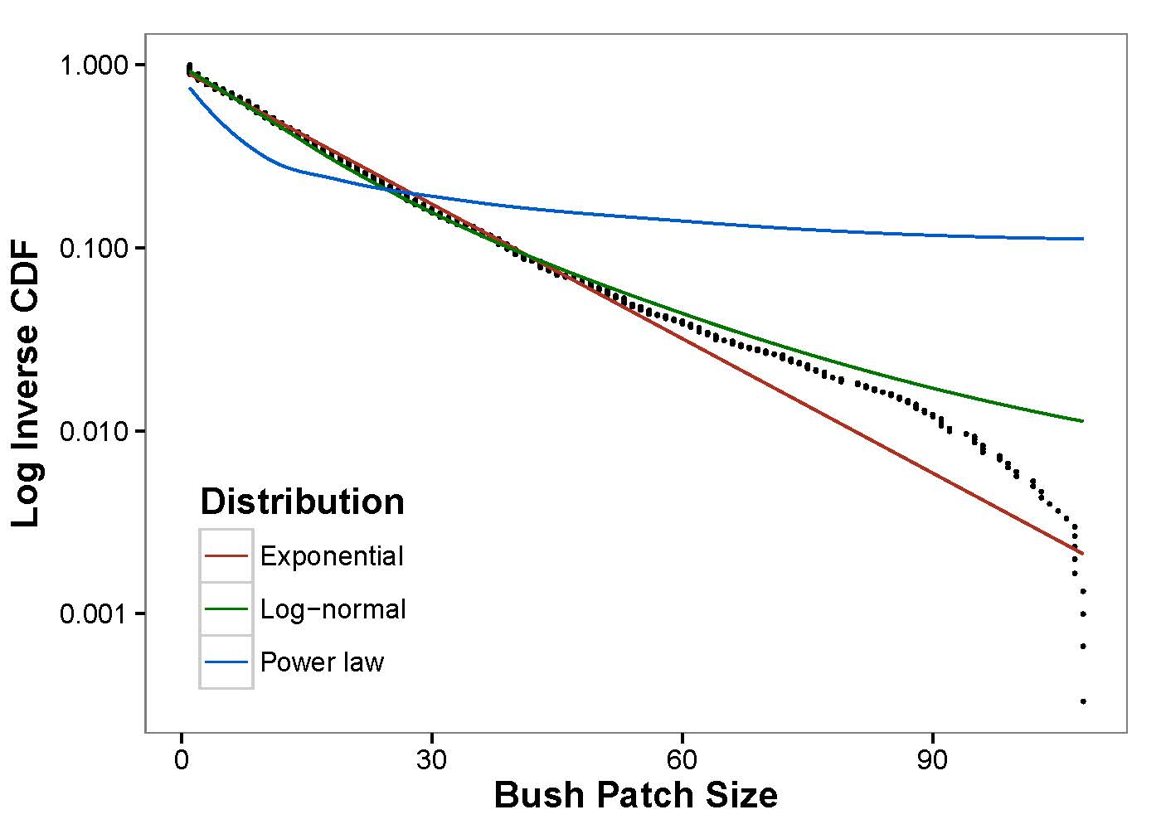

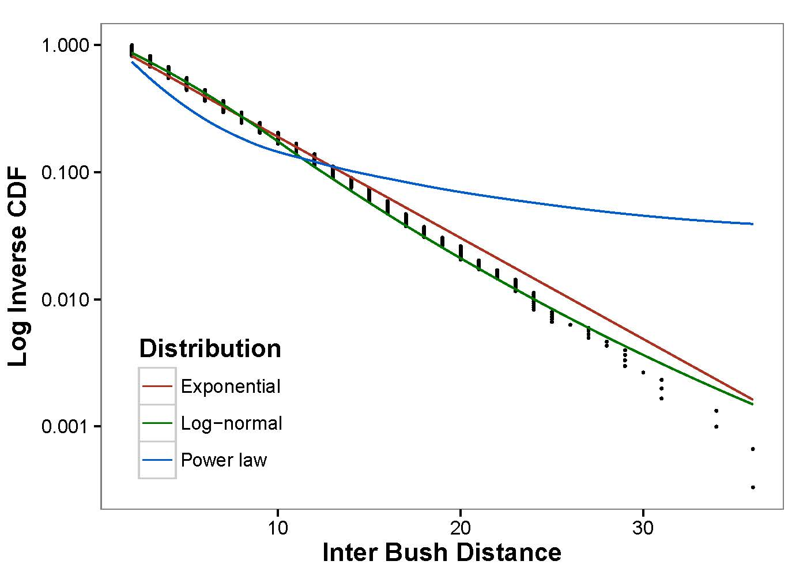

Africa (log-log and semi-log plots):

Surprisingly, only one of the burnt plots had a patch size distribution which followed a power law while another followed an exponential distribution. All the rest (14) followed a lognormal distribution which has no theoretical precedent. We neither know which interactions can cause these patterns nor the consequences on stability.

Inter patch distances followed exponential distributions without exceptions. This indicates that nearest neighbours are situated at a characteristic distance.

The following graphs are for Dzombo 1983. The third graph shows the proportion of biomass within 0.6 m from any patch as a function of patch size. This appears to decrease as a function of patch size.

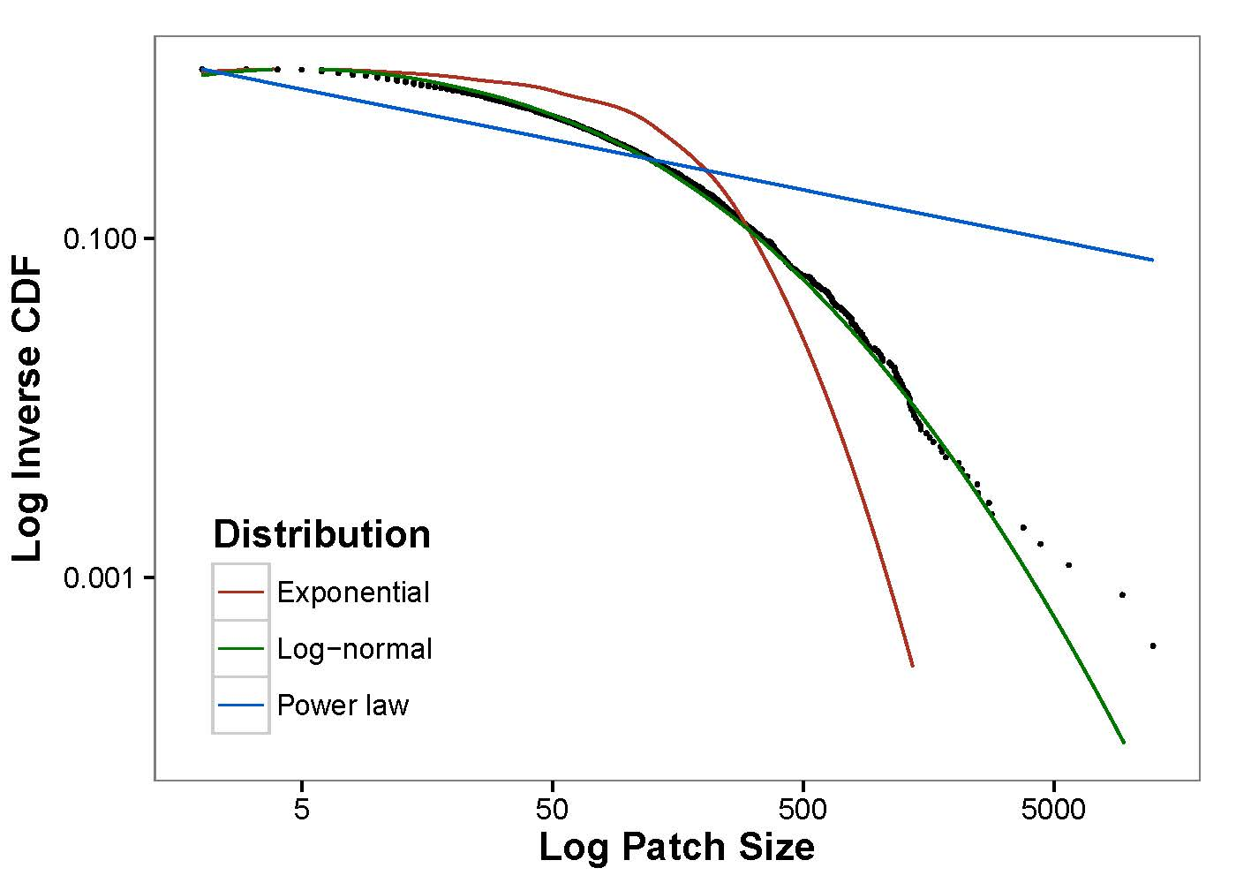

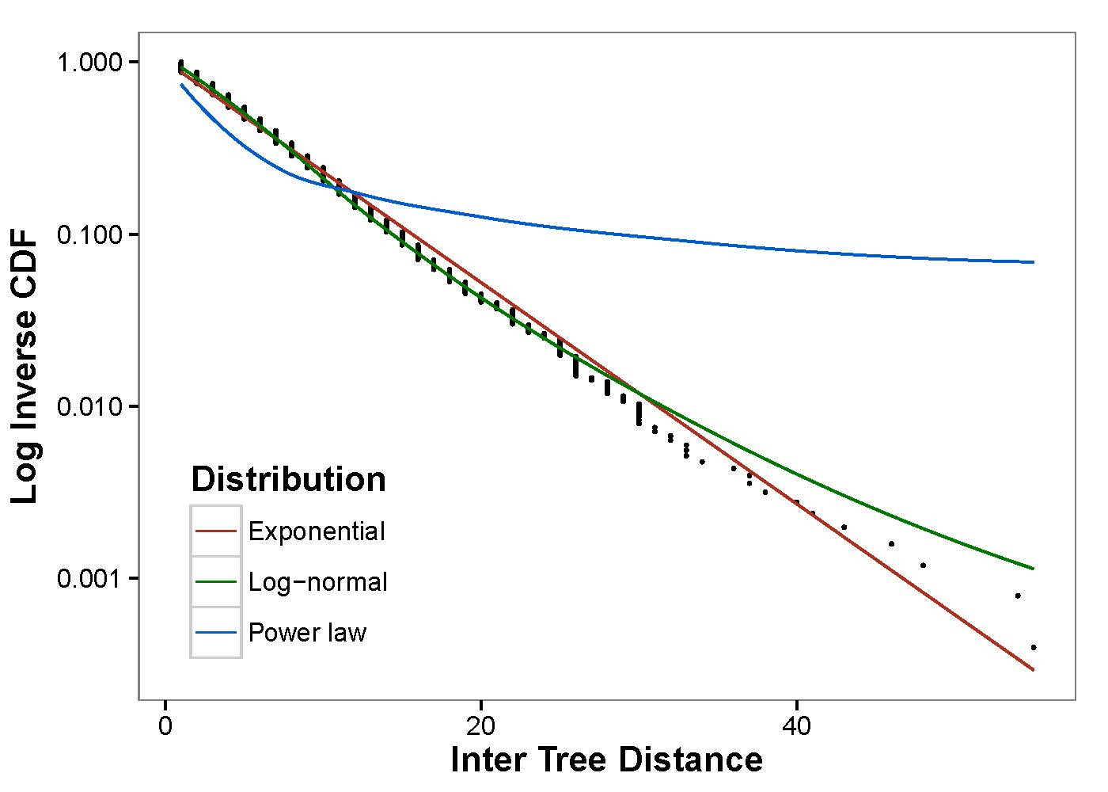

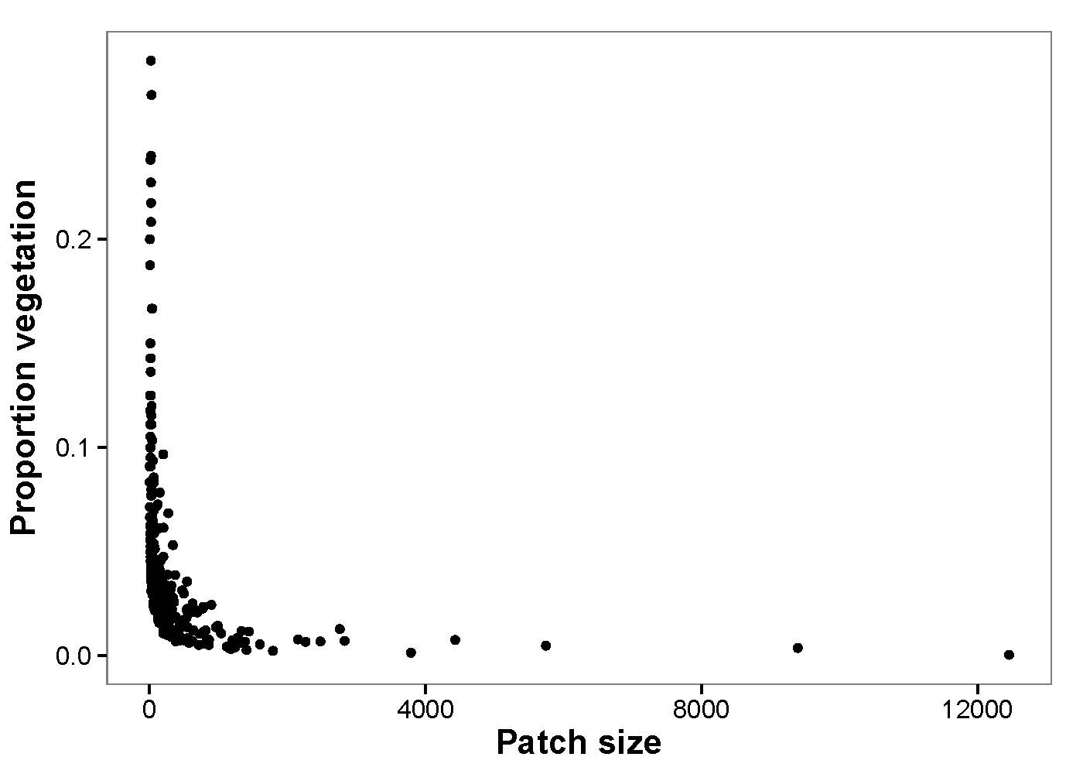

**Points to discuss**

What are the implications of lognormal distributions? What are the interactions which are capable of producing the results we see (exponential and lognormal distributions)? What interactions can we realistically expect in semi-arid ecosystems?

It is also worth thinking about whether a reanalysis of existing work is required to see if either the predicted patterns or real world patterns are misleading due to flawed analysis.

In the accompanying excel sheet, parameter values for the fitted exponential distributions for inter patch distances in Africa appear to follow an interesting pattern. In all four sites, these values decrease for the first three years before increasing in 2006.